A000-Asia-China-W Zhou-Chariot Head-Bronze-c 1046-771 BCE

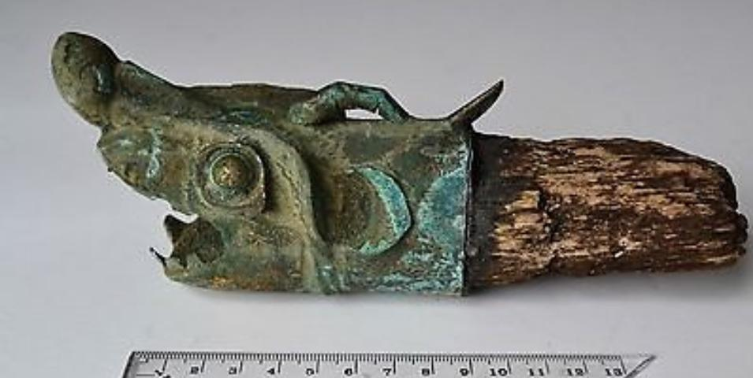

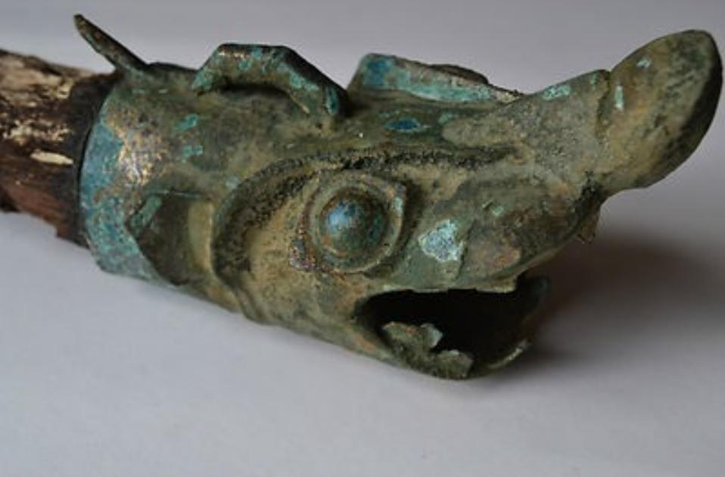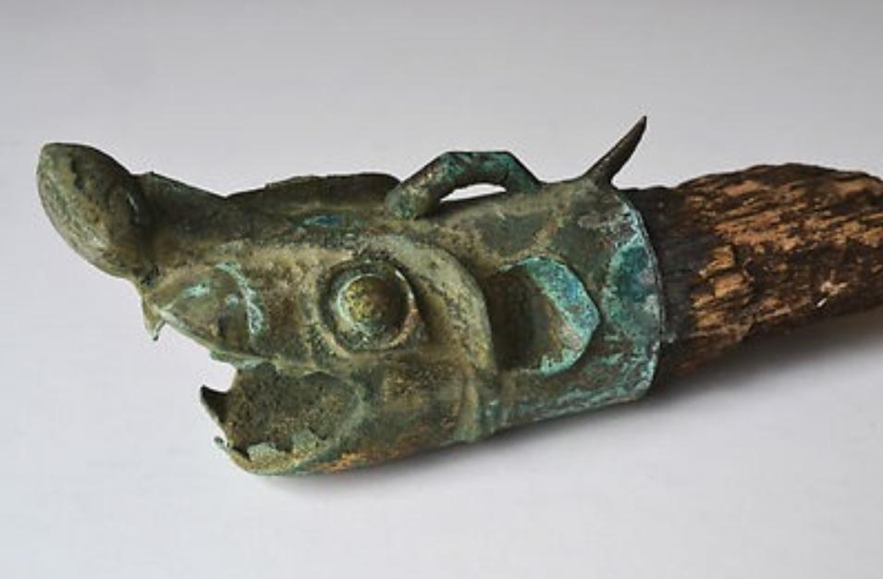

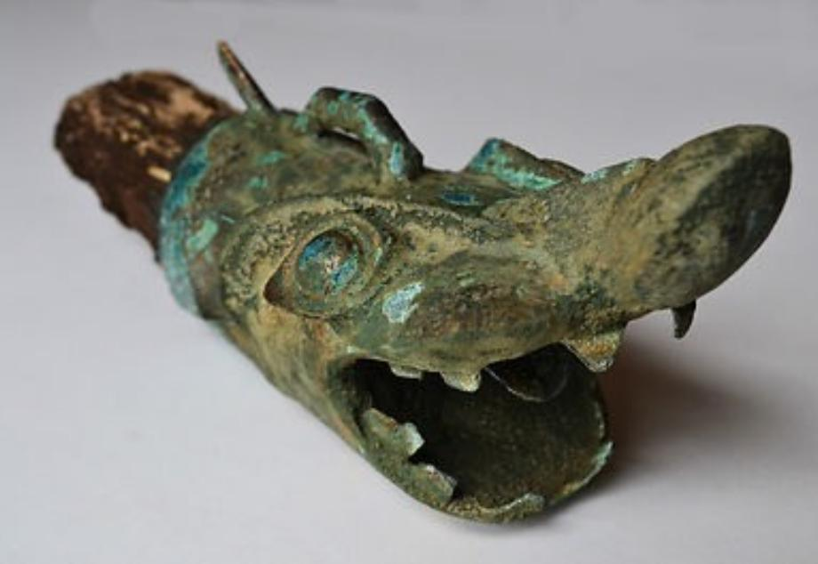

China-W Zhou-Chariot Head-Bronze-c 1046-771 BCE

Case No.: 5

**Accession No.**

**Formal Label:** China-W Zhou-Chariot Head-Bronze-c 1046-771 BCE

**Display Description:**

This Western Zhou Chariot ([戰車](http://en.wiktionary.org/wiki/戰車) , p. *zhànchē* lit. "war vehicle") Head in Bronze,c 1046-771 BCE, was fitted on the yuán or draught pole possibly and was probably from an entombment of a military commander who had used in his career as a charioteer as an apotropaic emblem.

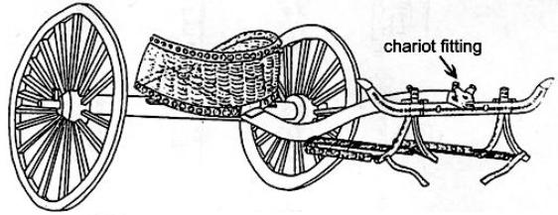

An ancient Chinese chariot ([戰車](http://en.wiktionary.org/wiki/戰車) , p. *zhànchē* lit. "war vehicle") with its alligator snout fitting (length 16.6 cm.) as reconstructed on the 3 m. long yuán or draught pole was excavated from burial M20 at Anyang Xiaotun. Chariot reconstruction after Shih Chang-ju, Hsiao-t'un: Pei-tsu Mu-tsang, *Academia Sinica* 22(1950), p. 28

The alligator as an apotropaic emblem on the battlefield suggests that its use was associated with its pugnacious ability to subdue its enemy by subduing and drowning it with great force, and when this power was transferred to the field of battle it would make the alligator chariot a formidable weapon through the power it derived from its animal emblem. Archaeological evidence indicates that the chariot in ancient China was used as an attack and pursuit vehicle on the Central Plains from around 1200 BCE (Beckwith 2009: 43, Ebrey 2006: 14). However, the invention of the chariot was traditionally assigned by the first century CE philologist Xǔ Shèn to the legendary Xia Dynasty minister [Xi Zhong](http://en.wikipedia.org/wiki/Xi_Zhong) who successfully used it at the Battle of Gan (甘之战) *ca*. 2100 BCE (Xǔ Shèn, wg [Hsü Shen p] *Shuowen Jiezi,* [*Zhu Pian*](http://en.wikipedia.org/w/index.php?title=Zhu_Pian&action=edit&redlink=1) (玉篇), "Chariot Section" (车部)). So in Chinese tradition the chariot had an ancient past that rendered it especially auspicious. And this auspiciousness was commuted to military commanders who used it in the late Shang period as a mobile staging device from which to direct troop movement, Therefore, the use of the alligator emblem on the chariot by a commander at Anyang, which was the center of power of the Shang state, would have indicated the high regard the commandery had for this apotropaic animal. This may be the reason why the use of the alligator motif is so rare in the archaeological record, because it may have had a restricted use to those in the high command. Located near the Zhangjiapo Village in Mawang Town of Chang'an District in Xian City and on the west bank of the Fenghe River, the Western Zhou Chariot Burial Pit is a typical sacrificial tomb of slave society. Archeologists have confirmed that the system of burying living people with the dead began in the Shang Dynasty (16th - 11th century BC). At that time, many alive slaves were buried with the dead, killed or after committing a suicide for the slave owner and nobles believed that the tombs were their residence in the spiritual world after their death.

**LC Classification:**

**Date or Time Horizon:**

**Geographical Area:**

**Map:**

**GPS coordinates:**

**Cultural Affiliation:**

**Media:**

**Dimensions:**

**Weight:**

**Condition:**

**Provenance:** "Old Chinese Zhou Dynasty bronze chariot head. Beautiful patina and coloring. The wooden pole is brittle and fragile. Inherited from a late relative."

**Discussion:**

The **Chinese alligator** (揚子鱷, (yáng zǐ è) *Alligator sinensis*) is one of only two known living species of *Alligator*, now native only to the lower reaches of the Yangtze River, along Yijiang and Taihu river-basin swamps and in the provinces of Jiangsu, Zhejiang, and Anhui. However, in the past its range was throughout most of southern China. Unlike its cousin, the American alligator, the Chinese alligator is armored over its entire body a feature of only a few Crocodilia, the order of large reptiles dating back 83.5 million years and named for the so called "pebble-worm" (κροκόδειλος Greek) texture of its armor, which resembles the Chinese Shang bronze body textures of ritual containers. However, while the term crocodilian can be used as an adjective for these creatures, their true animal is the Chinese alligator which is not a crocodile.

When reference is made to the alligator in Chinese sources, the reference is to the one genus of Chinese **Crocodilia**, *Alligator sinensis* (揚子鱷, yáng zǐ è) and not to the crocodile, (subfamily **Crocodylinae**) or **true crocodiles**, large aquatic tetrapods that live throughout the tropics in Africa, Asia (exclusive of China), the Americas and Australia. The **Crocodilia** (or **Crocodylia**) is the Latin order of large, predatory, semi-aquatic reptiles that appeared 83.5 million years ago in the Late Cretaceous period. Crocodilia are the closest living relatives of birds and both are the only known survivors of the **Archosauria, that also i**ncludes all extinct dinosaurs, extinct crocodilian relatives, and pterosaurs. There have been no true crocodiles in China.

*Alligator sinensis* is one of only two known living species of *Alligator*, which is now native only to the lower reaches of the Yangtze River, along Yijiang and Taihu river-basin swamps and in the provinces of Jiangsu, Zhejiang, and Anhui. However, in the past its range was throughout most of southern China.

INCLUDEPICTURE "G:\\Atlantica Central Data\\Application Data\\Microsoft\\`2013 Nov 12-29\\Local Settings\\Temp\\scl30.jpg" \* MERGEFORMATINET 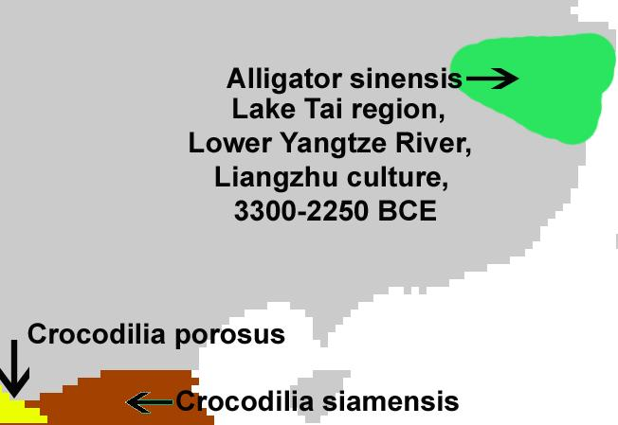

Range of *Alligator sinensis* coinciding with the jade-working, Neolithic, Liangzhu Culture, ca. 3300-2250 BCE.

Unlike its cousin, the American alligator, the Chinese alligator is armored over its entire body a feature of only a few Crocodilia, the order of large reptiles dating back 83.5 million years and named for the so called "pebble-worm" (κροκόδειλος Greek) texture of its body scales, which resembles the later Chinese Bronze Age Shang moiré pattern of curvilinear spirals that fills the interstitial surfaces on ritual bronze vessels. Hence we may infer that the Shang use of this artistic motif is related to *Alligator sinensis* as the archetypal embodiment of the Chinese concept of dragon, as most of the Shang bronze animal containers representative of mythical animals and dragons have this imagery emblazoned over their bodies.

INCLUDEPICTURE "G:\\Atlantica Central Data\\Application Data\\Microsoft\\`2013 Nov 12-29\\Local Settings\\Temp\\scl10.jpg" \* MERGEFORMATINET 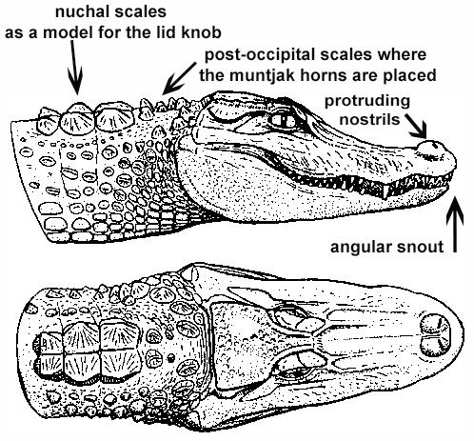

*Alligator sinensis* after Wermuth & Fuchs (1978)

In fact, this was from a biological and ecological point-of-view entirely reasonable. The Chinese alligators appeared when the monsoonal rains first inundated the patties: this was the harbinger of rice fructification, as the alligators scrambled up the slopes to secure a nesting site to lay their eggs that required access to at least 5 hours of sunlight each day as the females do not incubate their young.

**The Monsoon as the Dragon's Time**

The monsoon is a seasonal reversal of air currents accompanied by corresponding changes in precipitation (Ramage 1971). This is a seasonal change in atmospheric circulation and precipitation associated with the asymmetric heating of land and sea (Trenberth, Stepaniak, Caron 2000). Traditionally, "monsoon" refers to the rainy phase of a seasonally-changing pattern of which its alternative is a dry phase. Over oceans, the air temperature remains relatively stable for two reasons: because water has a relatively high specific heat (3.9 to 4.19 J g−1 K−1) (<http://www.engineeringtoolbox.com/specific-heat-fluids-d_151.html>), and because both conduction and convection will equilibrate a hot or cold surface with deeper water (up to 50 m.). In contrast, dirt, sand, and rocks have a lower specific heat (0.19 to 0.35 J g−1 K−1) (<http://www.engineeringtoolbox.com/specific-heat-solids-d_154.html>), which can only transmit heat into the earth by conduction and not by convection. Therefore, bodies of water stay at a more even temperature, while land temperature is more variable.

During warmer months sunlight heats the surfaces of both land and oceans, but land temperatures rise more quickly because it has a lower specific heat. As the land's surface becomes warmer, the air above it expands and an area of low pressure develops. Meanwhile, the ocean water which has a higher specific heat remains at a lower temperature than the land, and the air above it retains a higher pressure. This difference in pressure (lower over land and higher over water) causes sea breezes to flow from the ocean to the land, bringing moist air inland. This moist air rises to a higher altitude over land and then it flows back toward the ocean (thus completing the cycle). However, when the air rises, and while it is still over the land, the air cools with the higher elevation it attains. This decreases the air's ability to hold water, and this causes precipitation over the land. This is why summer monsoons cause so much rain over land.

**References:**

Chang, K.C., Xu, P. and Lu, L. 2005. *The formation of Chinese civilization: an archaeological perspective*. New Haven: Yale University Press.

Frazer, James George. 1911.The Magic Art and the Evolution of Kings, The Golden Bough, v. 2. London: Macmillan.

Li, Hui; Huang, Ying; Mustavich, Laura F.; Zhang, Fan; Tan, Jing-Ze; Wang, ling-E; Qian, Ji; Gao, Meng-He; Jin, Li. 2007. "Y chromosomes of prehistoric people along the Yangtze River," Human Genetics **122**: 383–388.

Wu, Li. 2014. "Holocene environmental change and its impacts on human settlement in the Shanghai Area, East China," Catena. **114**: 78–89

Zhang, Chia; Hsiao-Chun, Hung. 2008. "The Neolithic of Southern China–Origin, Development, and Dispersal,"Asian Perspectives. **47**:2, 309–310.

Zhou Ying. 2007. "The Dawn of the Oriental Civilization: Liangzhu site and Liangzhu culture. Beijing: China Intercontinental Press.